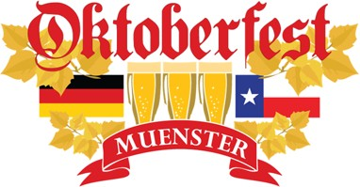
Danke for your support in one of Muenster’s signature events, the 7th Annual Oktoberfest!
• Where: Heritage Park in Muenster, TX (301 N Ash St, Muenster, TX 76252)
• When: Saturday, October 5, 2019 from 10:00AM– Midnight
Sunday, October 6, 2019 from 10:00AM– 6:00PM
• Estimated Attendance: Over 5,500
• Event Information: www.oktoberfestmuenster.com
Complete the form below and submit sponsorship form no later than: July 29, 2019

We can accept sponsors after this deadline, but we cannot guarantee that your logo/name will appear in event advertising as shown below.

 | $5,000 | $2,500 | $1,000 | $500 | $250
Entry Passes | 25 | 20 | 15 | 10 | 5
Tickets | $50 | $40 | $30 | $20 | $10
Event Display | Logo on projector | Logo on projector | Logo on projector | Name on projector | Name on projector
Social Media | Weekly shout out Aug & Sept | Weekly shout out Aug & Sept | Shout out last 3 weeks in Sept | Shout out last 2 weeks in Sept | Shout out week of event
Oktoberfest  Website | Logo | Logo | Logo | Name | Name
Thank You Ad in local newspaper | Logo | Logo | Logo | Name | Name
Event Poster | Logo | Logo

Organization/Business: Contact Person: Address: City: Zip: Phone: Email: Level of Support:
Please send your company logo to chamber@ntin.net as soon as possible to avoid missing out on all of the great marketing opportunities!

Muenster Chamber of Commerce 1000 East Division Street Muenster, TX 76252
940‐759‐2227 www.muensterchamber.com chamber@ntin.net

